**1. Create a simple cloud software application and provide it as a service using any Cloud Service Provider to demonstrate Software as a Service (SaaS).**

**PROCEDURE:**

STEP1: GOTO ZOHO.COM

STEP 2: LOGIN TO THE ZOHO.COM

STEP 3: SELECT ONE APPLICATION

STEP 4: ENTER APPLICATION NAME

STEP 5: CREATED NEW APPLICATION

STEP 6: SELECT ONE FORM

STEP 7: THE SOFTWARE HASE BEEN CREATED

**IMPLEMENTATION:**

**STEP1: GOTO ZOHO.COM STEP**

**STEP 2: LOGIN TO THE ZOHO.COM**

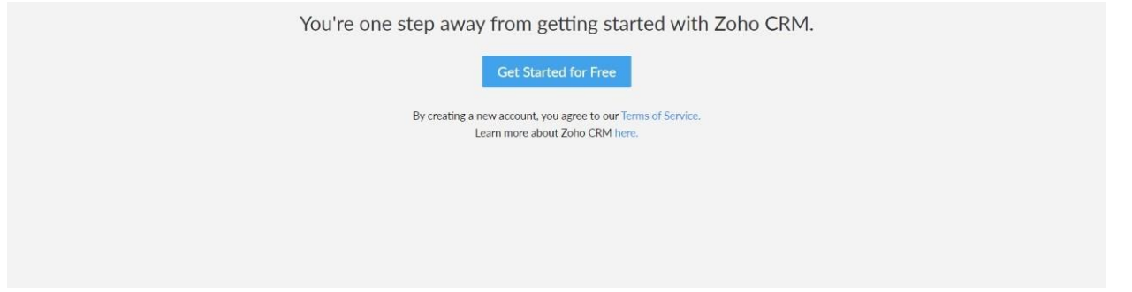

**STEP 3: SELECT ONE APPLICATION**

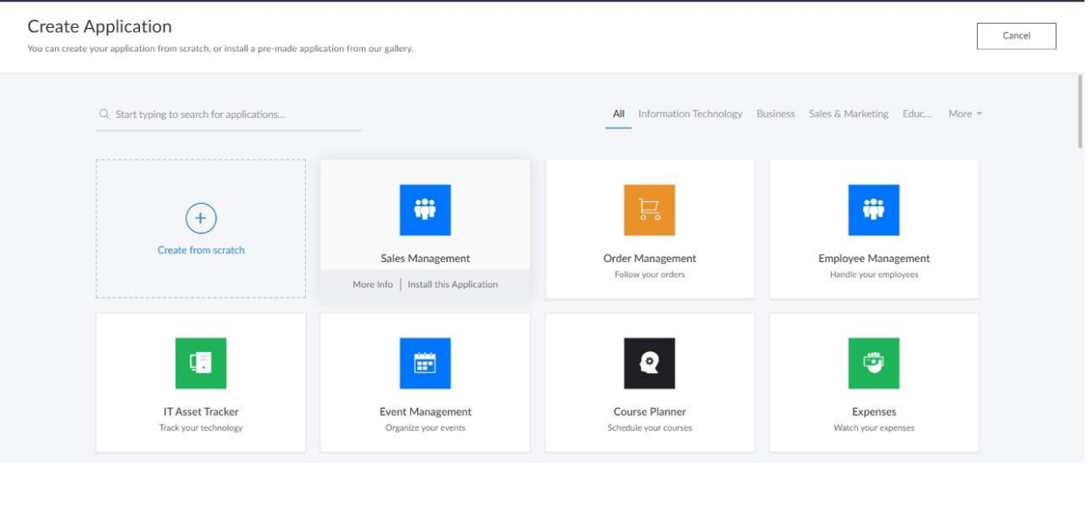

**STEP 4: ENTER APPLICATION NAME**

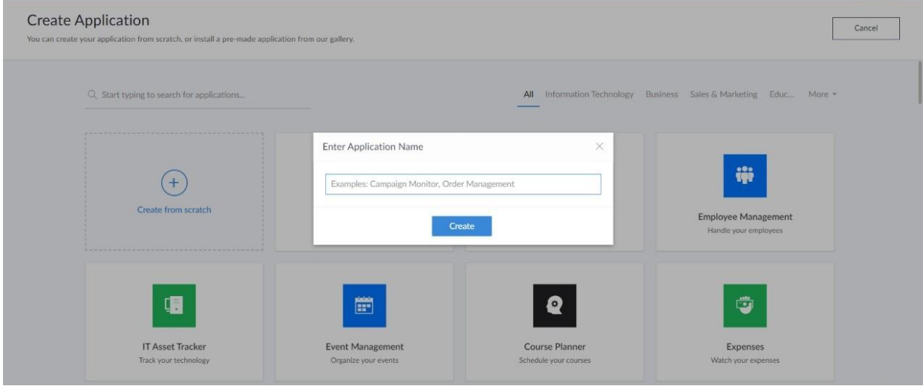

**STEP 5: CREATED NEW APPLICATION**

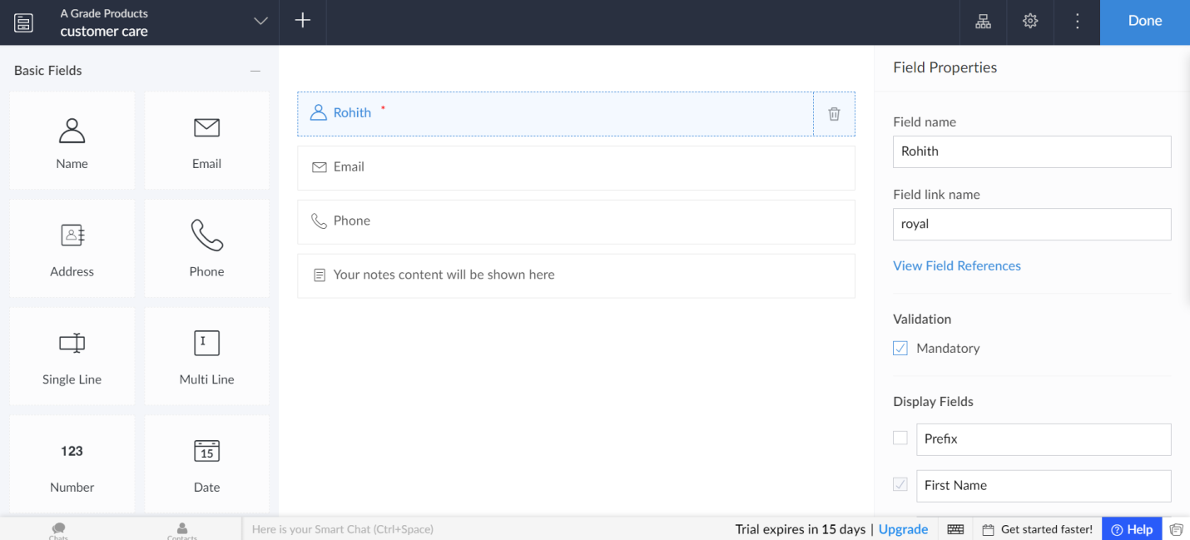

**STEP 6: SELECT ONE FORM**

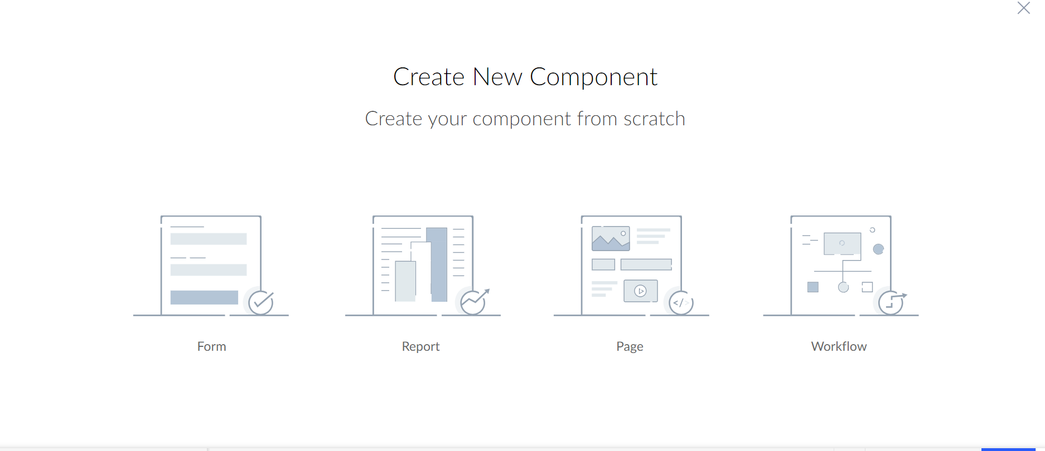

**STEP 7: THE SOFTWARE HASE BEEN CREATED**

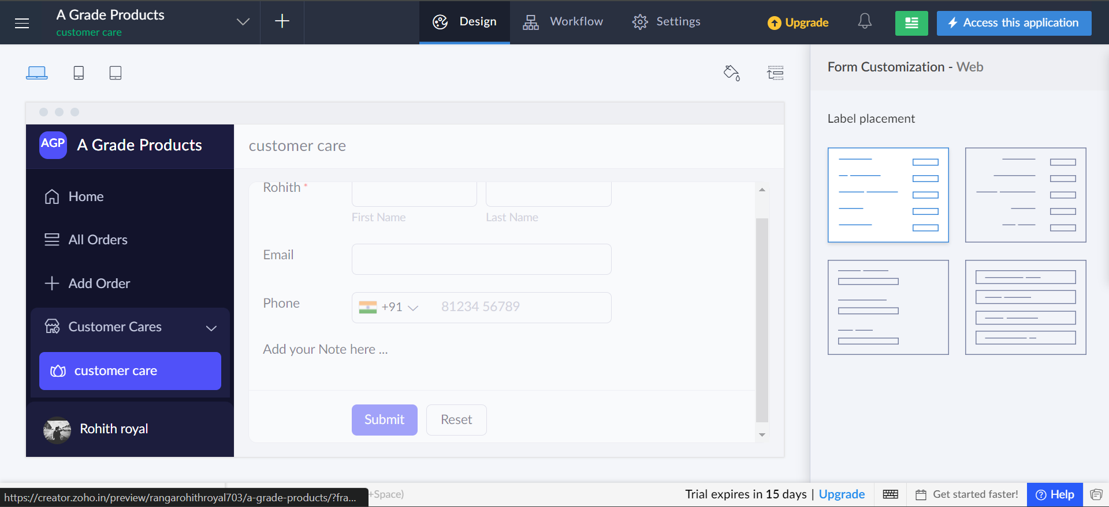

**2.Create a simple cloud software application for Flight Reservation System using any Cloud Service Provider to demonstrate SaaS**

**PROCEDURE:**

STEP1: GOTO ZOHO.COM

STEP 2: LOGIN TO THE ZOHO.COM

STEP 3: SELECT ONE APPLICATION

STEP 4: ENTER APPLICATION NAME

STEP 5: CREATED NEW APPLICATION

STEP 6: SELECT ONE FORM

STEP 7: THE SOFTWARE HASE BEEN CREATED

**IMPLEMENTATION:**

**STEP1: GOTO ZOHO.COM STEP**

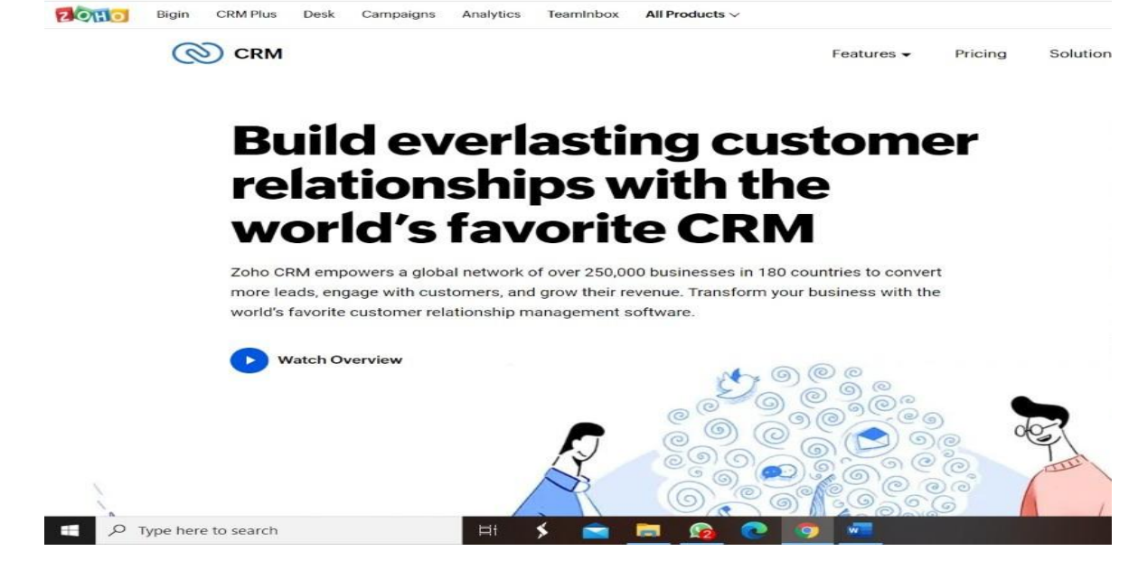

**STEP 2: LOGIN TO THE ZOHO.COM**



**STEP 3: SELECT ONE APPLICATION**



**STEP 4: ENTER APPLICATION NAME**



**STEP 5: CREATED NEW APPLICATION**

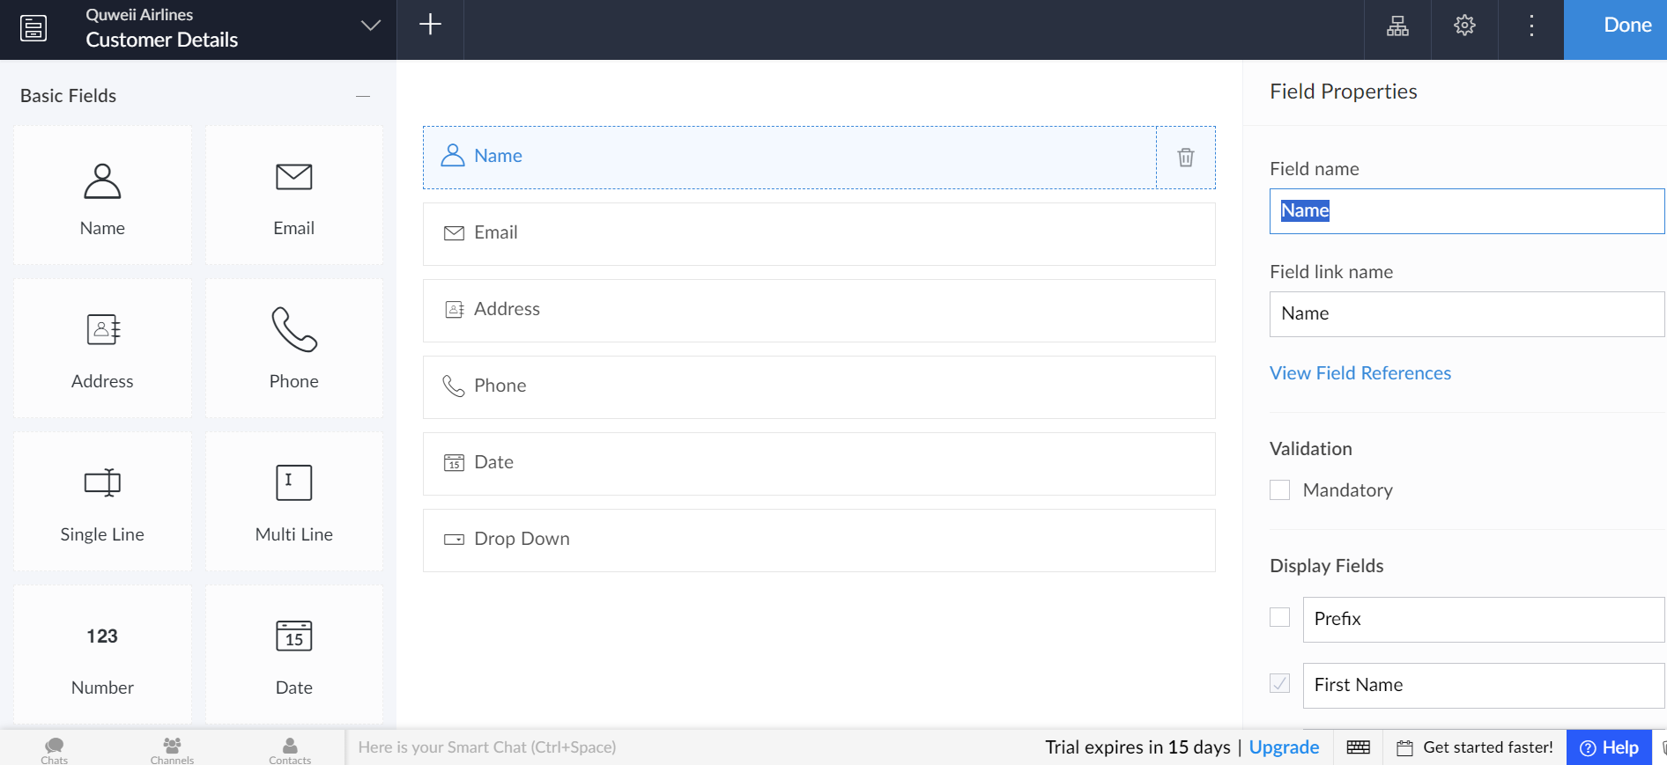

**STEP 6: SELECT ONE FORM**



**STEP 7: THE SOFTWARE HASE BEEN CREATED**

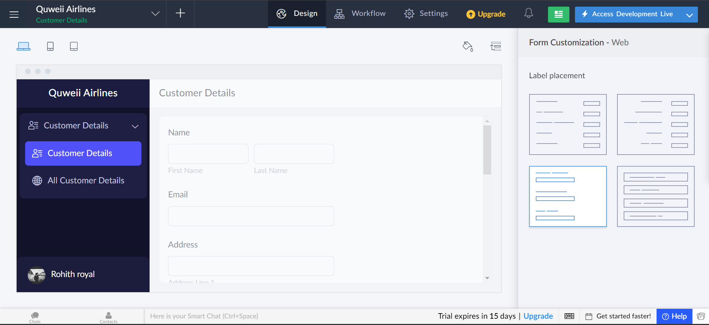

**EXP NO 3:** CREATE A SIMPLE CLOUD SOFTWARE APPLICATION FOR PROPERTY BUYING & RENTAL PROCESS (IN CHENNAI CITY) USING ANY CLOUD SERVICE PROVIDER TO DEMONSTRATE SAAS.

**DATE:**

AIM: To Create a simple cloud software application for Property Buying & Rental process (In Chennai city) using any Cloud Service Provider to demonstrate SaaS.

**PROCEDURE:**

step1: Go to zoho.com.

step 2: Log into the zoho.com.

step 3: Select one application step.

step4: Enter application name as property buying & rental.

step 5: Created new application as property buying & rental.

step 6: Select one form s

tep 7: The software has been created

**IMPLEMENTATION:-**

**STEP1: GOTO ZOHO.COM**

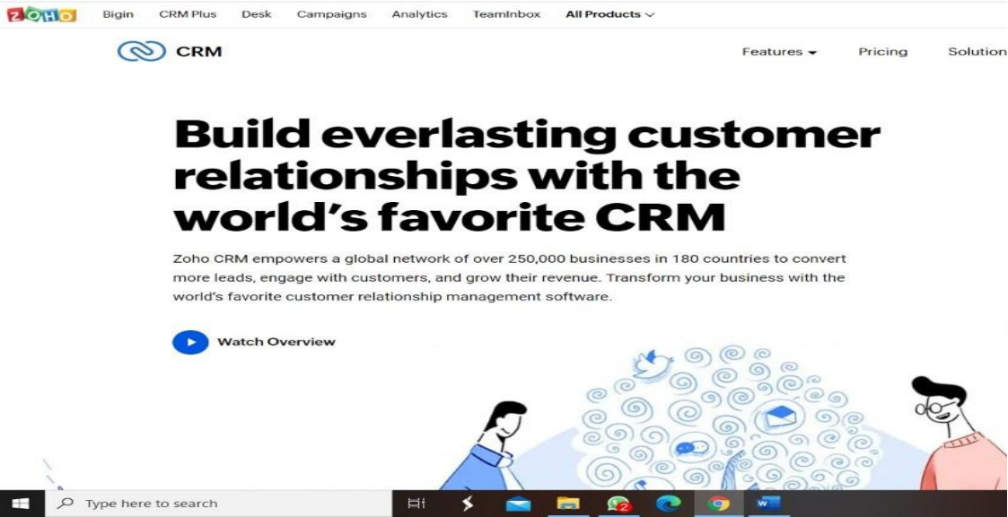

**STEP 2: LOGIN TO THE ZOHO.COM**



**STEP 3: SELECT ONE APPLICATION**

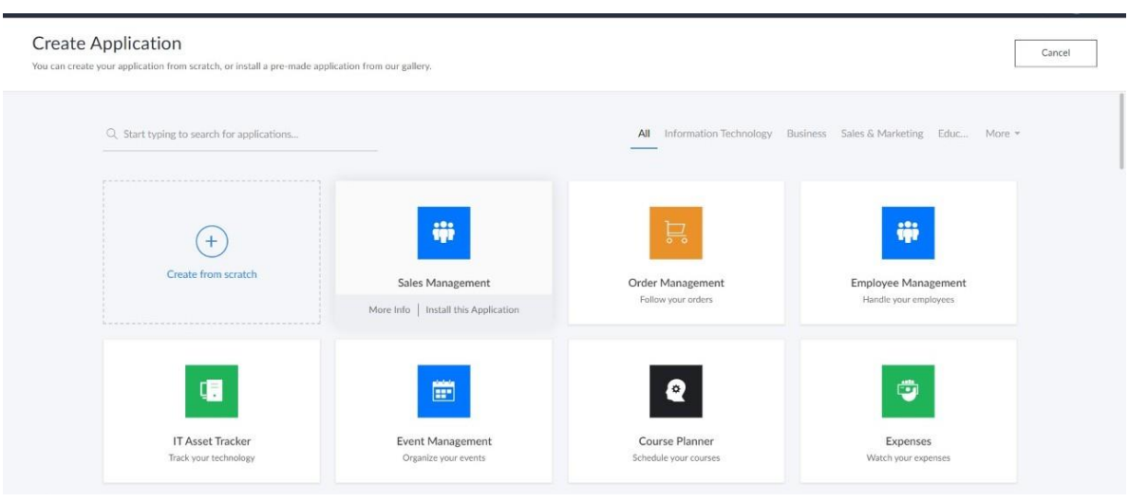

**STEP 4: ENTER APPLICATION NAME**

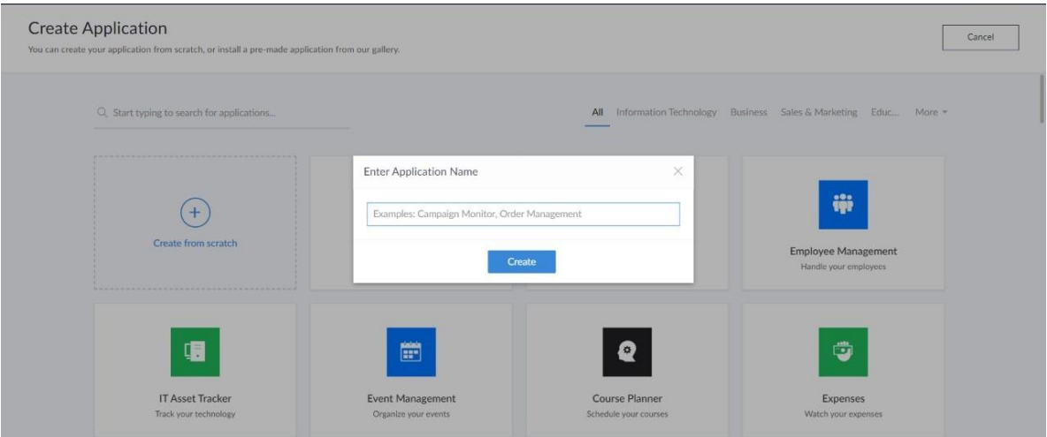

**STEP 5: CREATED NEW APPLICATION**

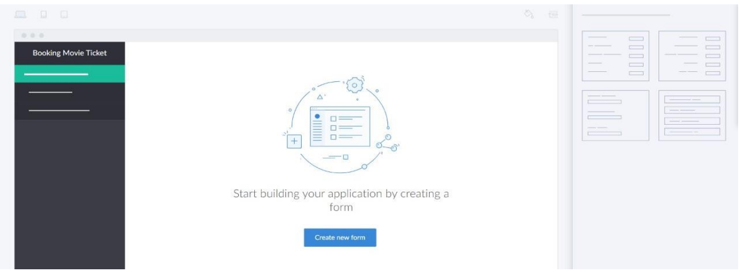

**STEP 6: SELECT ONE FORM**

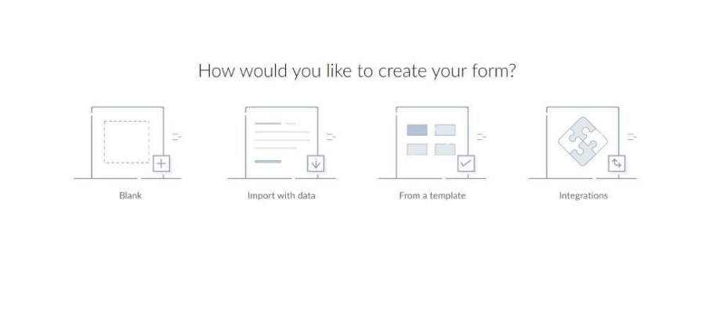

**STEP 7: THE SOFTWARE HASE BEEN CREATED**

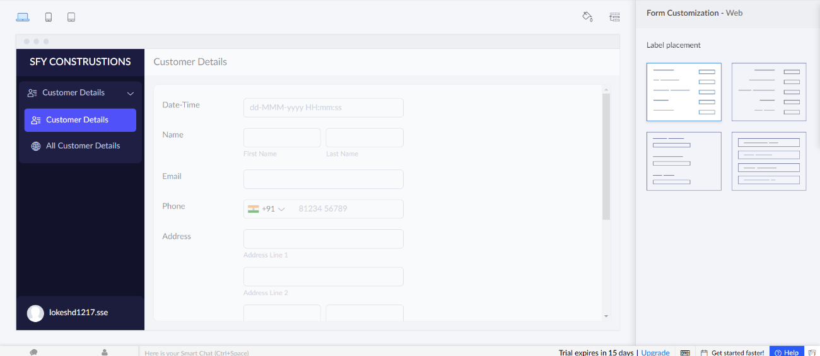

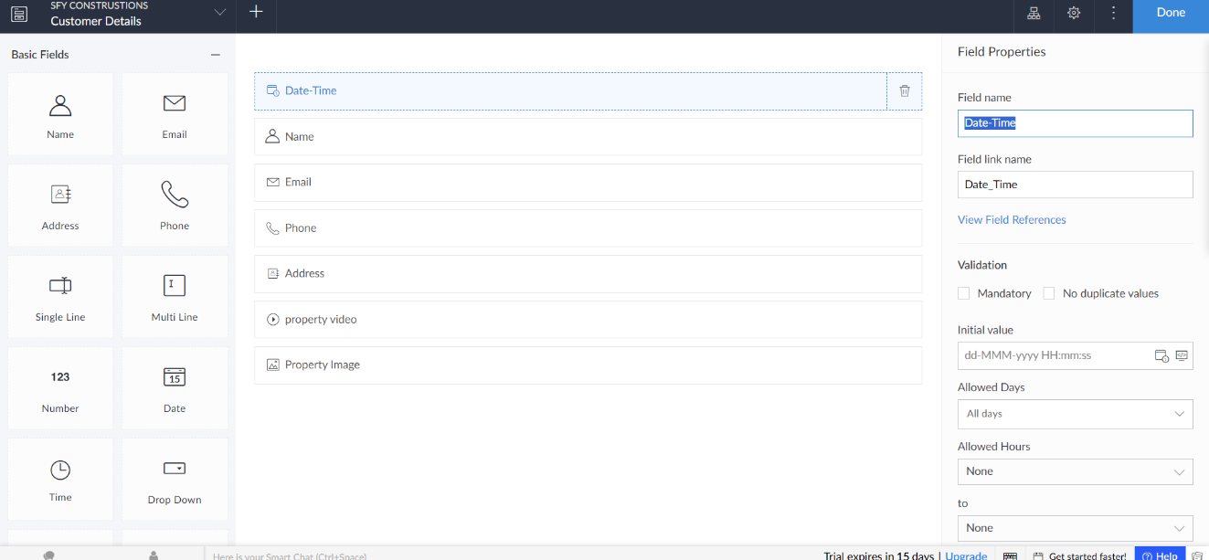

**EXP NO 4**: CREATE A SIMPLE CLOUD SOFTWARE APPLICATION FOR CAR BOOKING RESERVATION SYSTEM USING ANY CLOUD SERVICE PROVIDER TO DEMONSTRATE SAAS.

**DATE:**

**AIM:** To Create a simple cloud software application for Car Booking Reservation System using any Cloud Service Provider to demonstrate SaaS.

PROCEDURE:

step1: Go to zoho.com.

step 2: Log into the zoho.com.

step 3: Select one application step.

step4: Enter application name as Car Booking Reservation System.

step 5: Created new application as Car Booking Reservation System.

step 6: Select one form

step 7: The software has been created

**IMPLEMENTATION:-**

**STEP1: GOTO ZOHO.COM**



**STEP 2: LOGIN TO THE ZOHO.COM**



**STEP 3: SELECT ONE APPLICATION**



**STEP 4: ENTER APPLICATION NAME**



**STEP 5: CREATED NEW APPLICATION**



**STEP 6: SELECT ONE FORM**



**STEP 7: THE SOFTWARE HASE BEEN CREATED**

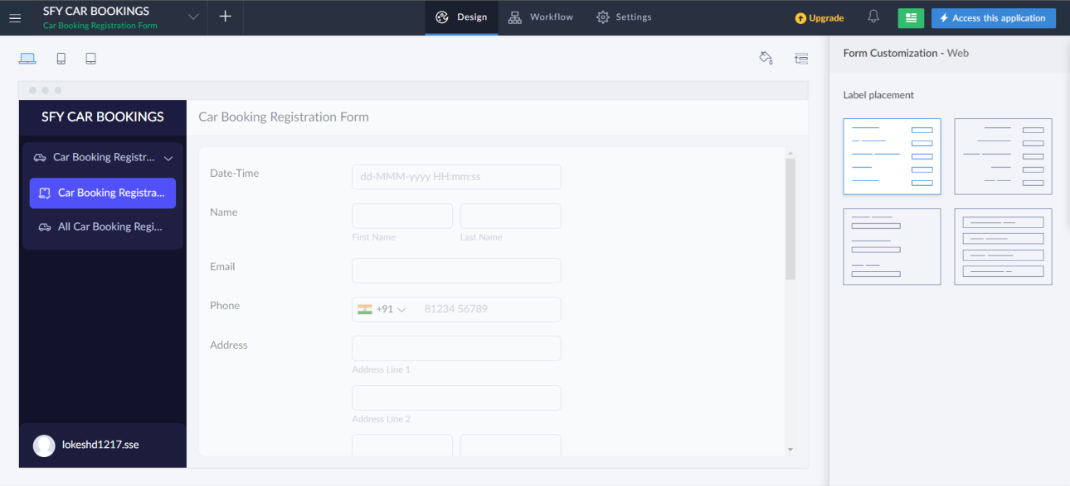

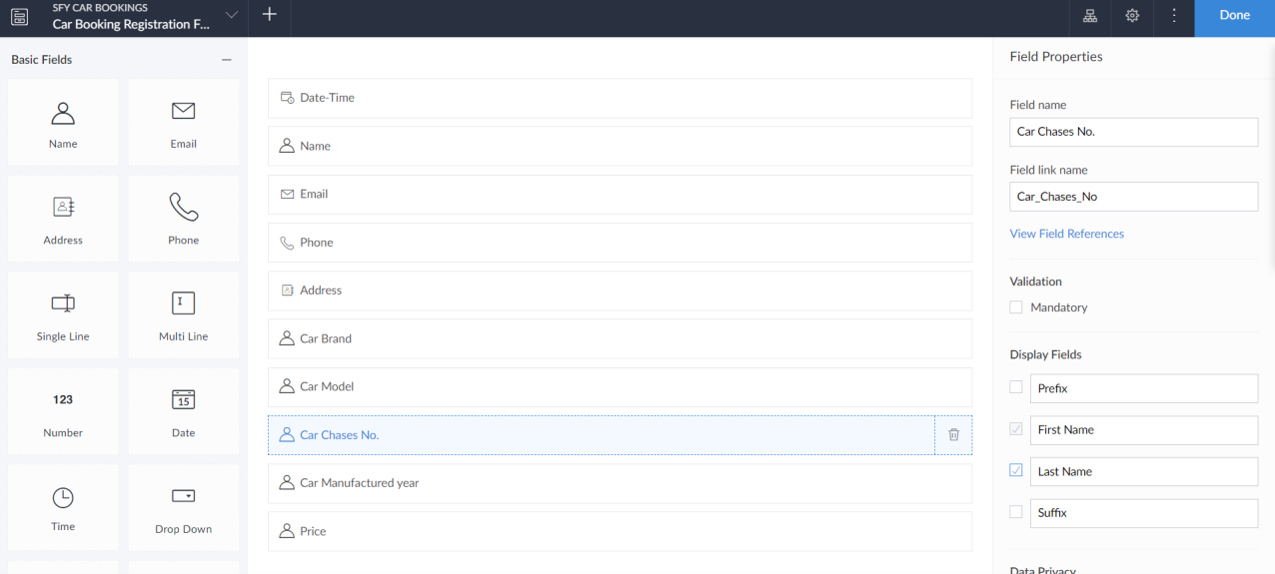

**EXP NO 5:** CREATE A SIMPLE CLOUD SOFTWARE APPLICATION FOR LIBRARY BOOK RESERVATION SYSTEM FOR SIMATS LIBRARY USING ANY CLOUD SERVICE PROVIDER TO DEMONSTRATE SAAS

**DATE:**

AIM: To Create a simple cloud software application for Library book reservation system for SIMATS library using any Cloud Service Provider to demonstrate SaaS

**PROCEDURE:**

step1: Go to zoho.com.

step 2: Log into the zoho.com.

step 3: Select one application step.

step4: Enter application name as library book reservation system.

step 5: Created new application as library book reservation system.

step 6: Select one form

step 7: The software has been created

**IMPLEMENTATION:-**

**STEP1: GOTO ZOHO.COM**



**STEP 2: LOGIN TO THE ZOHO.COM**



**STEP 3: SELECT ONE APPLICATION**



**STEP 4: ENTER APPLICATION NAME**



**STEP 5: CREATED NEW APPLICATION**



**STEP 6: SELECT ONE FORM**



**STEP 7: THE SOFTWARE HASE BEEN CREATED**

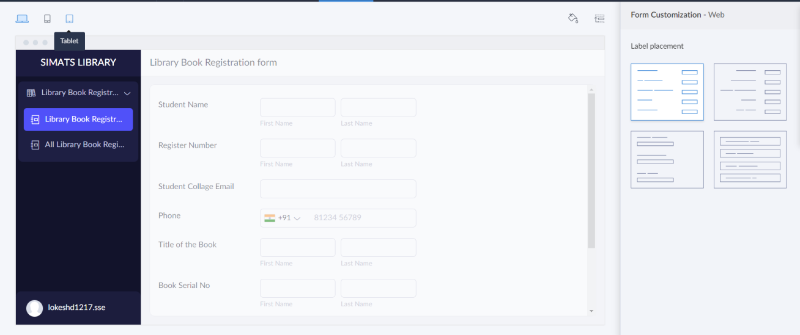

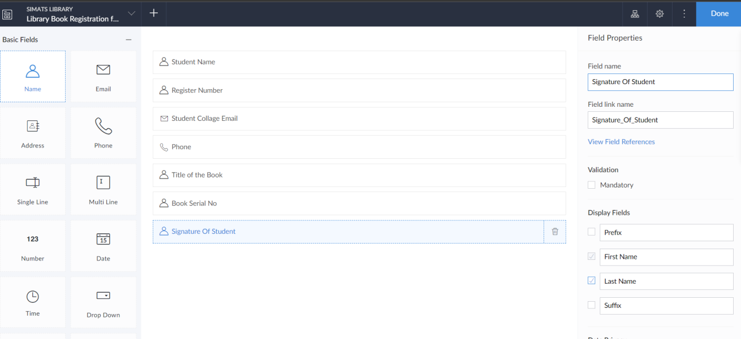

**EXP NO 6:** CREATE A SIMPLE CLOUD SOFTWARE APPLICATION FOR PRODUCT SELLING USING ANY CLOUD SERVICE PROVIDER TO DEMONSTRATE SAAS.

**DATE:**

**AIM:** To create a simple cloud software application for product selling using any cloud service provider to demonstrate saas.

**PROCEDURE:**

step1: Go to zoho.com.

step 2: Log into the zoho.com.

step 3: Select one application step.

step4: Enter application name as product selling.

Step 5: Created new application as product selling.

step 6: Select one form

step 7: The software has been created.

**IMPLEMENTATION:-**

**STEP1: GOTO ZOHO.COM**



**STEP 2: LOGIN TO THE ZOHO.COM**



**STEP 3: SELECT ONE APPLICATION**



**STEP 4: ENTER APPLICATION NAME**



**STEP 5: CREATED NEW APPLICATION**



**STEP 6: SELECT ONE FORM**



**STEP 7: THE SOFTWARE HASE BEEN CREATED**



